**Kitchen Story**

**─ Anupam Deo**

# COMPANY_**NAME**: **Kitchen Story**

**This code is developed by** :-  **Anupam Deo**

**The code for this project is hosted at “https://github.com/AnupamDeo/Kitchen_Story_Project.git”.**

# Overview

Kitchen Story is an e-commerce portal that lets people shop basic food items on their website. The website needs to have the following features:

* A search form in the home page to allow entry of the food items to be purchased by the customer.
* Based on item details entered, it will show available food items with price.
* Once a person selects an item to purchase, they will be redirected to the list of available items. In the next page, they are shown the complete breakout of the order and details of the payment to be made in the payment gateway. When payment is done, they are shown a confirmation page with details of the order.

# Module of the project

1. MVC model
2. Visual studios
3. Node js
4. Angular js
5. HTML
6. javascript
7. css
8. Type scrip

**Home**

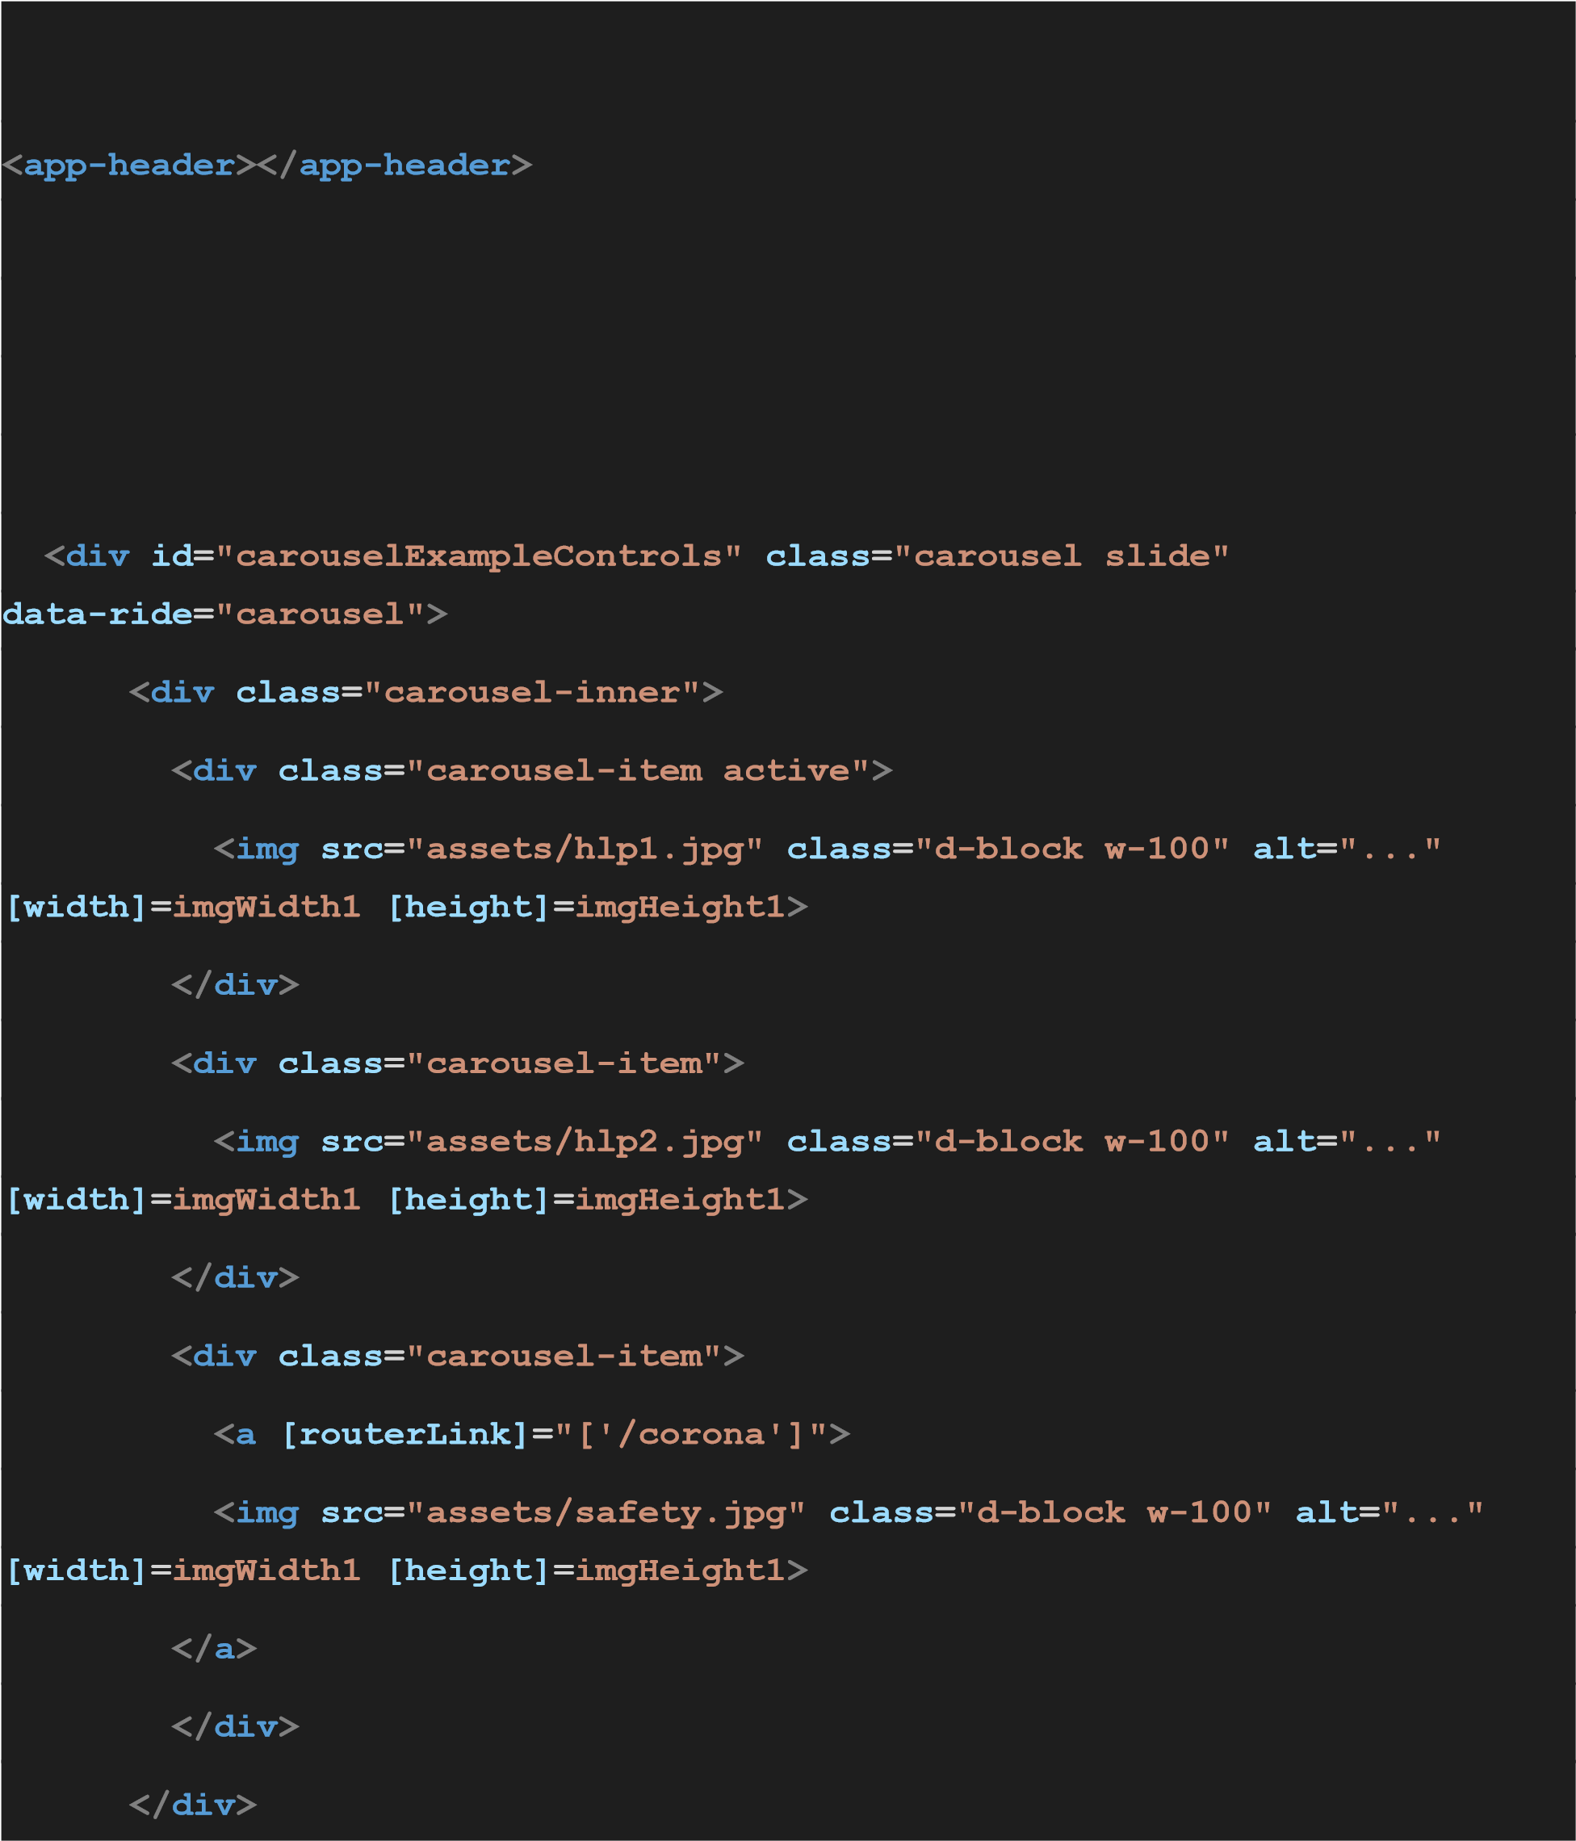

|  |
| --- |
| **< a class = "carousel-control-prev" href = "#carouselExampleControls"** |
| **role = "button" data-slide = "prev" >** |
| **< span class = "carousel-control-prev-icon"** |
| **aria-hidden = "true" ></ span >** |
| **< span class = "sr-only" > Previous </ span >** |
| **</ a >** |
| **< a class = "carousel-control-next" href = "#carouselExampleControls"** |
| **role = "button" data-slide = "next" >** |
| **< span class = "carousel-control-next-icon"** |
| **aria-hidden = "true" ></ span >** |
| **< span class = "sr-only" > Next </ span >** |
| **</ a >** |
| **</ div >** |
|  |
| **< br >** |
| **< br >< br >** |
| **< div class = "container" >** |
| **< div class = "card" >** |
| **< div class = "card-body" >** |
| **< p > Here we provide different range of food items required for your** |
| **kitchen. </ p >** |
| **</ div >** |
| **</ div >** |
|  |
| **< div class = "container" >** |
| **< div class = "jumbotron" >** |
| **< img src = "assets/hjumbo.jpg" width = "1000" >** |
| **< p > We have best offers and at reasonable prices </ p >** |
| **< a class = "btn btn-outline-primary"** |
| **[routerLink] = "['/Fooditems']" role = "button" > Wanna tryout some </ a >** |
| **</ div >** |
| **</ div >** |
| **</ div >** |
| **< app-footer ></ app-footer >** |
| **< router-outlet ></ router-outlet >** |
|  |

**Login**

|  |
| --- |
| **< app-header ></ app-header >** |
| **< br />** |
| **< body >** |
| **< div class = "container" >** |
| **< p > &nbsp; </ p >** |
| **< p > Login Here!!! </ p >** |
| **< div class = "card" >** |
| **< div class = "card-body" >** |
| **< form novalidate (ngSubmit) = "save(logForm)" #logForm = "ngForm" >** |
| **< div class = "container" >** |
| **< div class = "form-group row mb-6" >** |
| **< label class = "col-md-2 col-form-label"** |
| **for = "emailId" > Email: </ label >** |
| **< div class = "col-md-8" >** |
| **< input type = "text" required** |
| **id = "emailId"** |
| **name = "email"** |

|  |
| --- |
| **[(ngModel)] = login.email** |
| **#email = "ngModel"** |
| **pattern = "[a-z0-9._%+-]+@[a-z0-9.-]+\.[a-z]{2,4}$"** |
|  |
| **[ngClass] = "{'is-invalid':(email.touched||email.dirty)&&!email.valid}** |
| **" />** |
|  |
| **< span class = "invalid-feedback" >** |
| **< span *ngIf = email.errors?.required >** |
| **Email is required** |
| **</ span >** |
|  |
| **< span *ngIf = email.errors?.pattern >** |
| **please enter valid email format** |
| **</ span >** |
| **</ span >** |
| **</ div >** |
| **</ div >** |
| **< div class = "form-group row mb-2" >** |
| **< label class = "col-md-2 col-form-label"** |
| **for = "passwordId" > Password: </ label >** |
| **< div class = "col-md-8" >** |
| **< input type = "password" required id = "passwordId" minlength = "8"** |
| **name = "password" [(ngModel)] = login.password #passwordVar = "ngModel"** |
| **[ngClass] = "{'is-invalid':(passwordVar.touched ||** |
| **passwordVar.dirty) && !passwordVar.valid }" />** |
| **< span class = "invalid-feedback" >** |
| **< span *ngIf = passwordVar.errors?.required >** |
| **The password should be entered....** |
| **</ span >** |
| **< span *ngIf = passwordVar.errors?.minlength >** |
| **The password should be atleast 8 characters long....** |
| **</ span >** |
| **</ span >** |
| **</ div >** |
| **</ div >** |
| **< button class = "btn btn-success" type = "submit"** |
| **[disabled] = "!logForm.valid" > Submit </ button >** |
| **</ div >** |
|  |
| **</ form >** |
|  |
| **</ div >** |
|  |
| **</ div >** |
| **< br >** |
| **< p > If you are a new user** |
| **< a [routerLink] = "['/register']" > Regiter Here </ a ></ p >** |
|  |
| **< br >** |
| **</ div >** |
| **</ body >** |
| **< app-footer ></ app-footer >** |

**Admin**

**< app-header ></ app-header >**

|  |
| --- |
| **< br >** |
| **< br >** |
| **< button type = "button" class = "btn btn-primary"** |
| **[routerLink] = "['/add']" > Add </ button >** |
| **< div class = 'table-responsive' >** |
| **< table class = 'table table-bordered' >** |
| **< thead >** |
| **< tr class = "bg-info" >** |
| **< th > Fruits </ th >** |
| **< th > Name </ th >** |
| **< th > Cost </ th >** |
| **< th > Edit </ th >** |
| **< th > Delete </ th >** |
|  |
| **</ tr >** |
| **</ thead >** |
| **< tbody >** |
| **< tr *ngFor = 'let mov of Food' >** |
| **< img [src] = 'mov.Img' [width] = 'imgWidth'** |
| **[height] = 'imgHeight'** |
| **[style.borderRadius.px] = 'imgRadius' >** |
| **< td > {{mov.Name}} </ td >** |
| **< td > {{mov.Cost}} </ td >** |
| **< td >< button > Edit </ button ></ td >** |
| **< td >< button (click) = "onDelete(mov.Name)" > Delete </ button ></ td >** |
| **</ tr >** |
| **</ tbody >** |
| **</ table >** |

**</ div >**

**Output screenshot**

**Home**

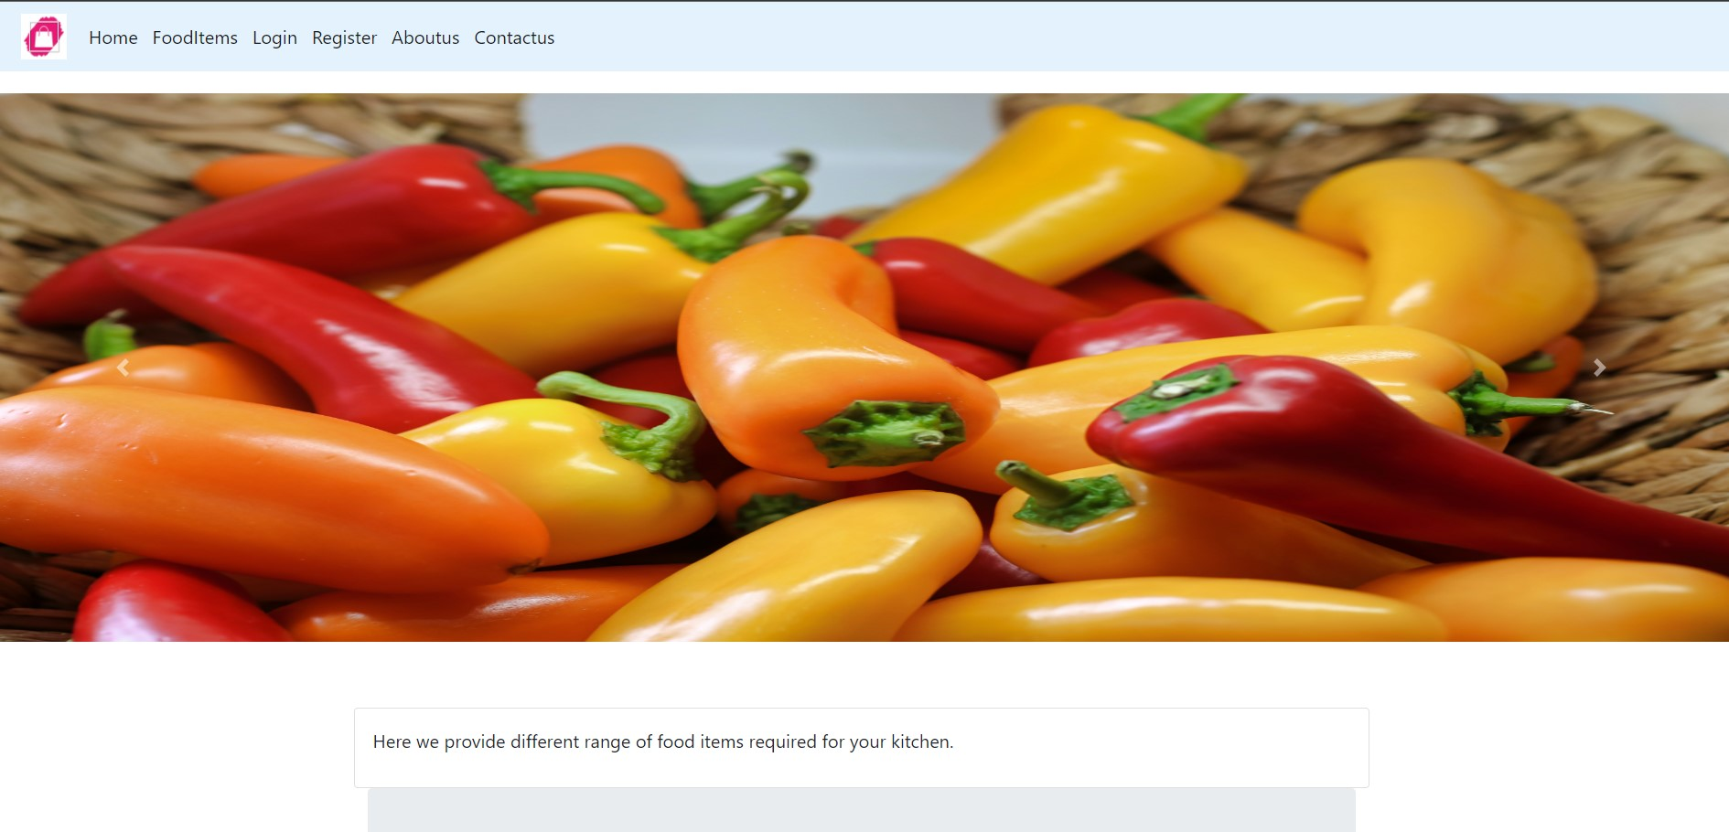

**Food items**

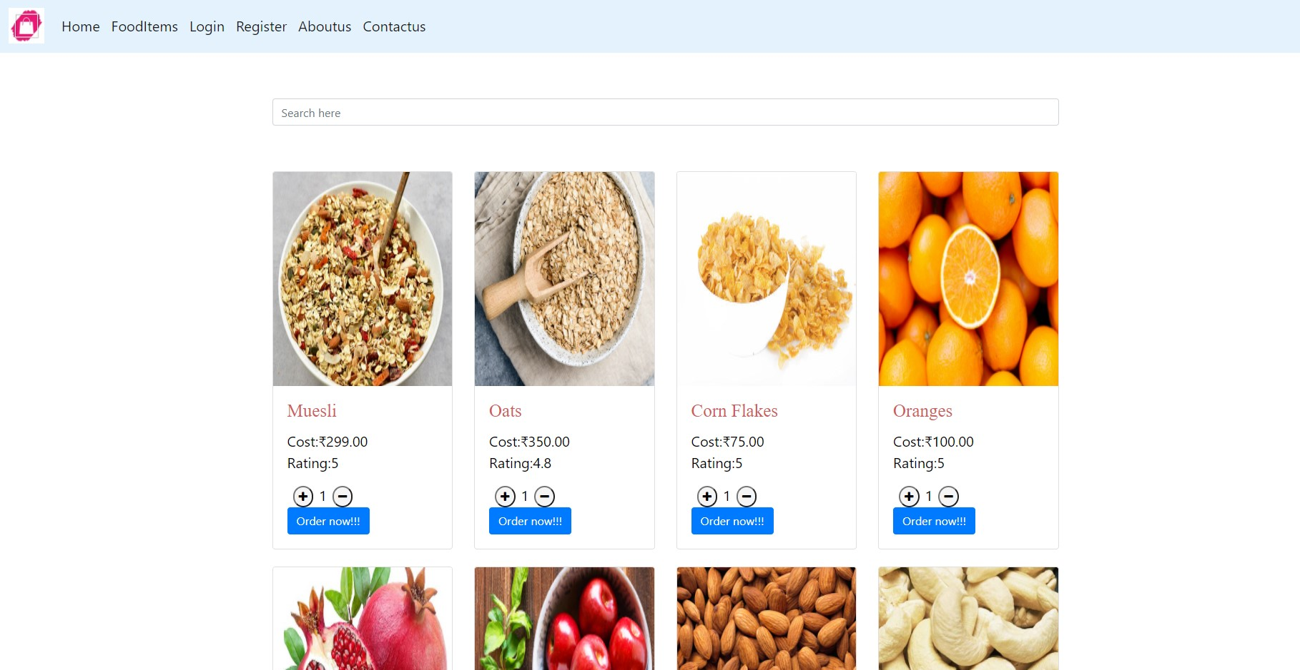

**Login**

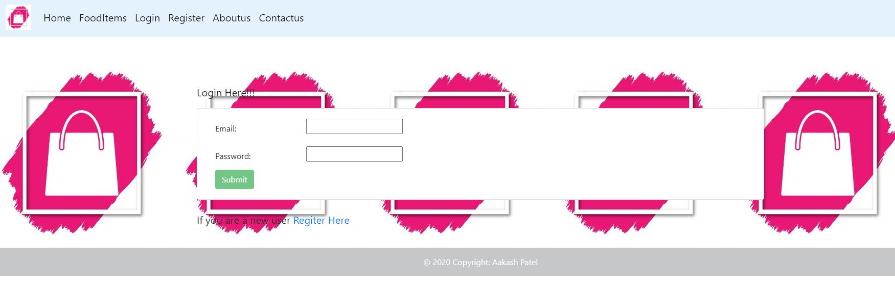

**Register**

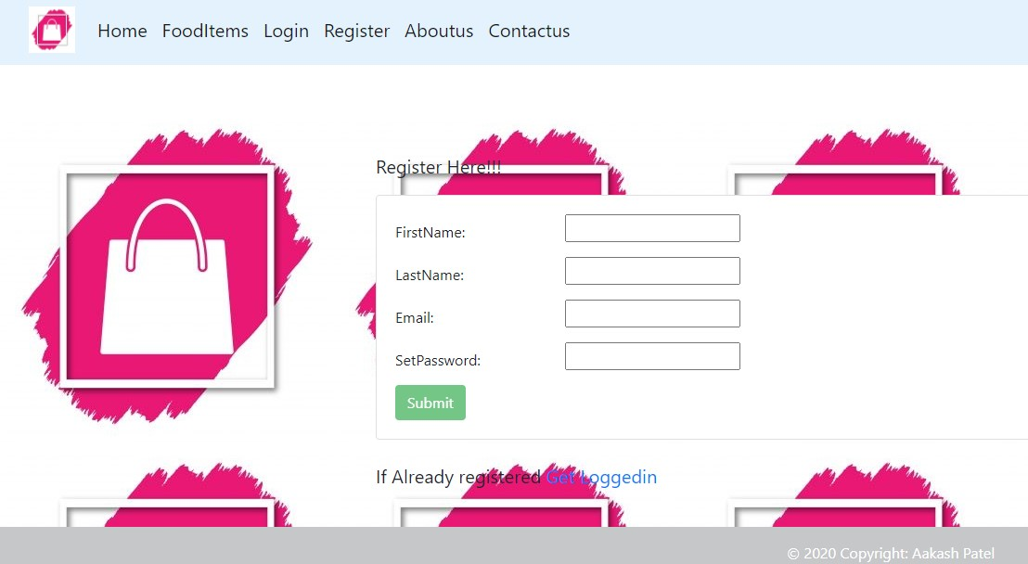

**Admin Login**

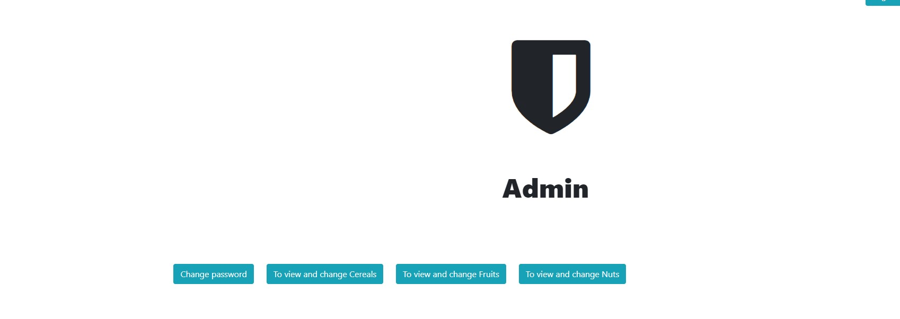

**Change Password**

